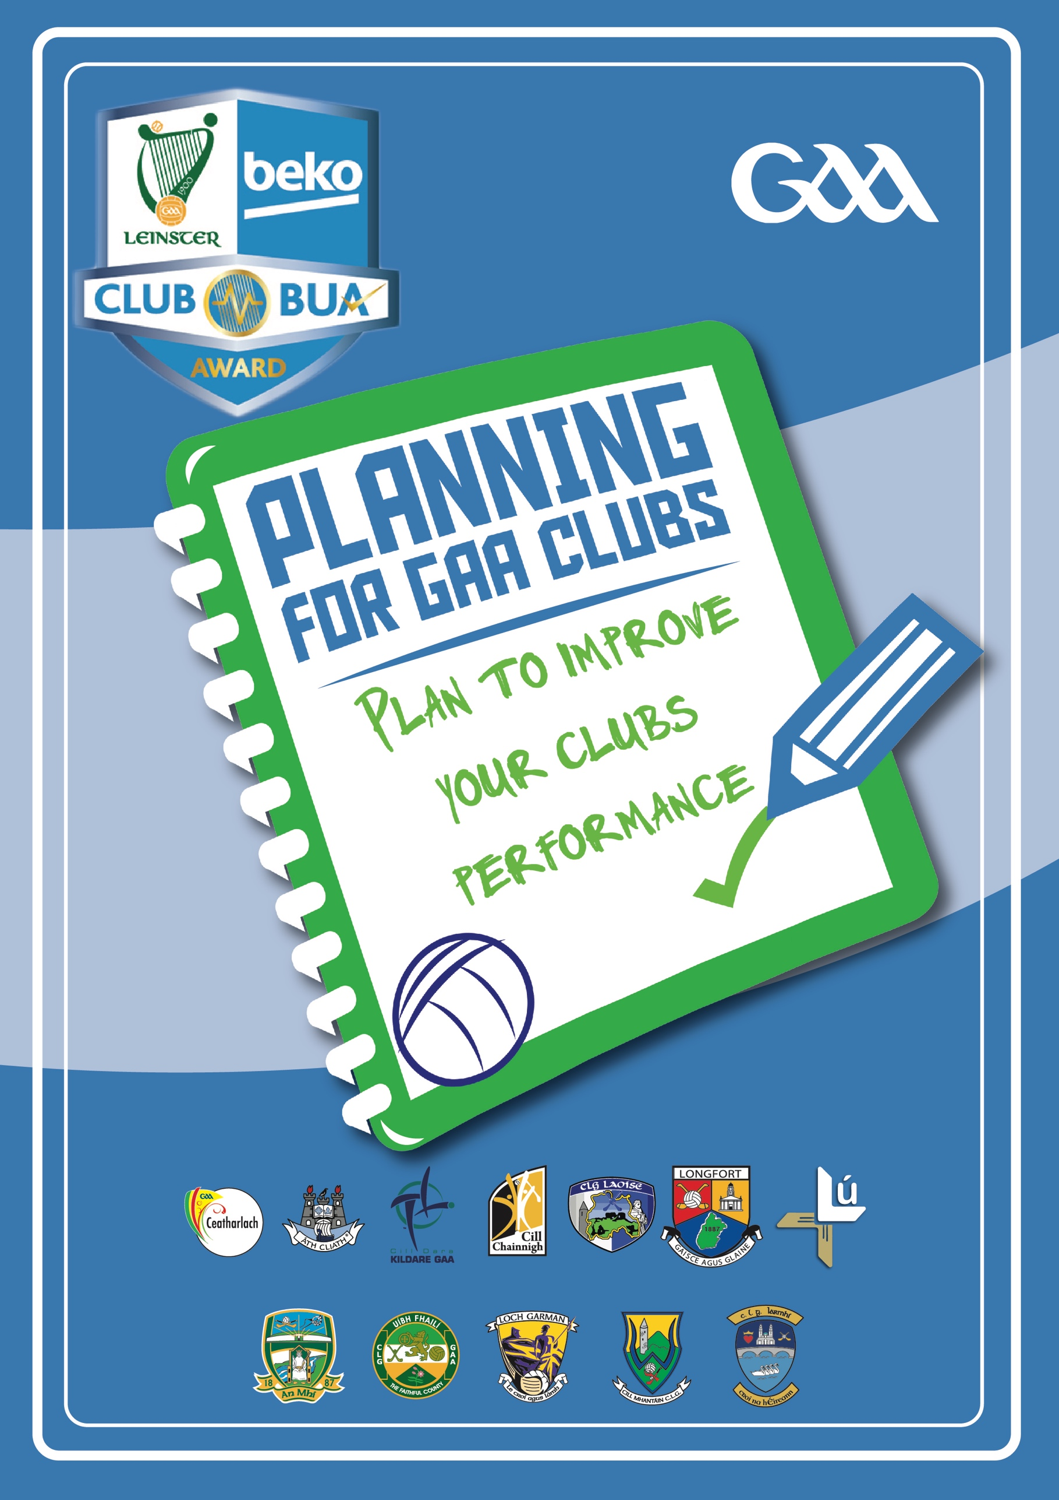
What is the Programme?
Club BUA is a resource developed by Leinster Games Developed Section as part of overall GAA Club Development Programme, modified and adapted for use by clubs under the auspices of Leinster GAA.
The planning programme is an initiative by Leinster GAA and its delivery is supported province wide by Games Development Officers, focused on improving the coaching and games aspect within your club in line with good practice.
The purpose of club BUA is to provide clubs with a practical tool to assist your club get an understanding of:
Where your club is now
Where Your Club Wants to Be
How your club will get there
Club BUA is user friendly and designed in such a way to enable and empower club members to carry out a review of current situation and develop a plan to improve the overall performance of your club teams.
Once the details below been completed your club, please return the application form to info.leinster@gaa.ie.
Club Detail

Club Name

Club Address

Club Secretary

Email

Club Coaching Officer

WHERE YOU WANT TO BE

In this section review the checklists and through a SWOT Analysis exercise identify what are the Strengths, Weaknesses, Opportunities and Threats related to your clubs. Carry out this exercise in a group setting.

Strengths | Weaknesses
Opportunities | Threats

WHERE YOU WANT TO BE

rEVIEW THE RESULTS OF THE swot aNALYSIS AND AS A GROUP, AGREE WHAT SHOULD BE THE CLUBS EXPECTAIONS FOR THE NEXT 1, 2 OR 3 YEARS. iN A GROUP SET OUT WHAT THE KEY PRIORITIES ARE FOR THE CLUB GOING FORWARD. tHESE SHOULD BE CRITICAL TO THE IMPROVEMENT OF THE CLUB.

What are the four key priorities for your Club in tHE NEXT 1, 2 OR 3 YEARS?

6.
7.

tURAS cOACHING pRINCAPALS

wHEN YOUR COACHES COACH, DOES IT LOOK LIKE THIS?

t – Testing & challenging, all players should be challeneged to improve at their level

U – understand the player is at the center of the game and provide indiviualised development

R – Resembeles the game (Game based)

a – all the players involves all of the time. lots of touches, lots of decisions.

s – Should always be an enjoyable, appropriate & holistic gaa experience.

HOW YOUR CLUB WILL GET THERE
hAVING COMPLETED THE PREVIOUS EXERCISES AND IDENTIFIED WHAT THE KEY PRIORITIES ARE – THE NEXT STEP IS TO SET OUR HOW THE CLUB WILL ACHIEVE ITS ECXPECTATION BY SETTING WHAT WILL BE DONE, hOW IT WILL BE DONE, BY wHOM AND BY WHEN. tHIS IS THE MOST CRITICAL PART OF THE PROCESS AS IT IS A SHARED CONTRACT OR AGREEMENT MADE BETWEEN THE MEMBERS COMMITTED TO IMPROVING THE CLUB. tHIS AGAIN should BE COMPLETED BY ASKING THE OVERALL GROUP TO SPLIT AND TAKE EACH PRIROTY AREA AND GIVE FEEDBACK ON FOR AGREEMENT.

a GROUP SHOULD BE ESTABLISED TO OVERSEE IMPLEMENTATION OF THE ACTION PLAN AND IT SHOULD BE REVIEWED AND EVALUATED ON AT CLUB MEETINGS.

Action Plan Template

Area | Actions | When | Who
Club notes:

