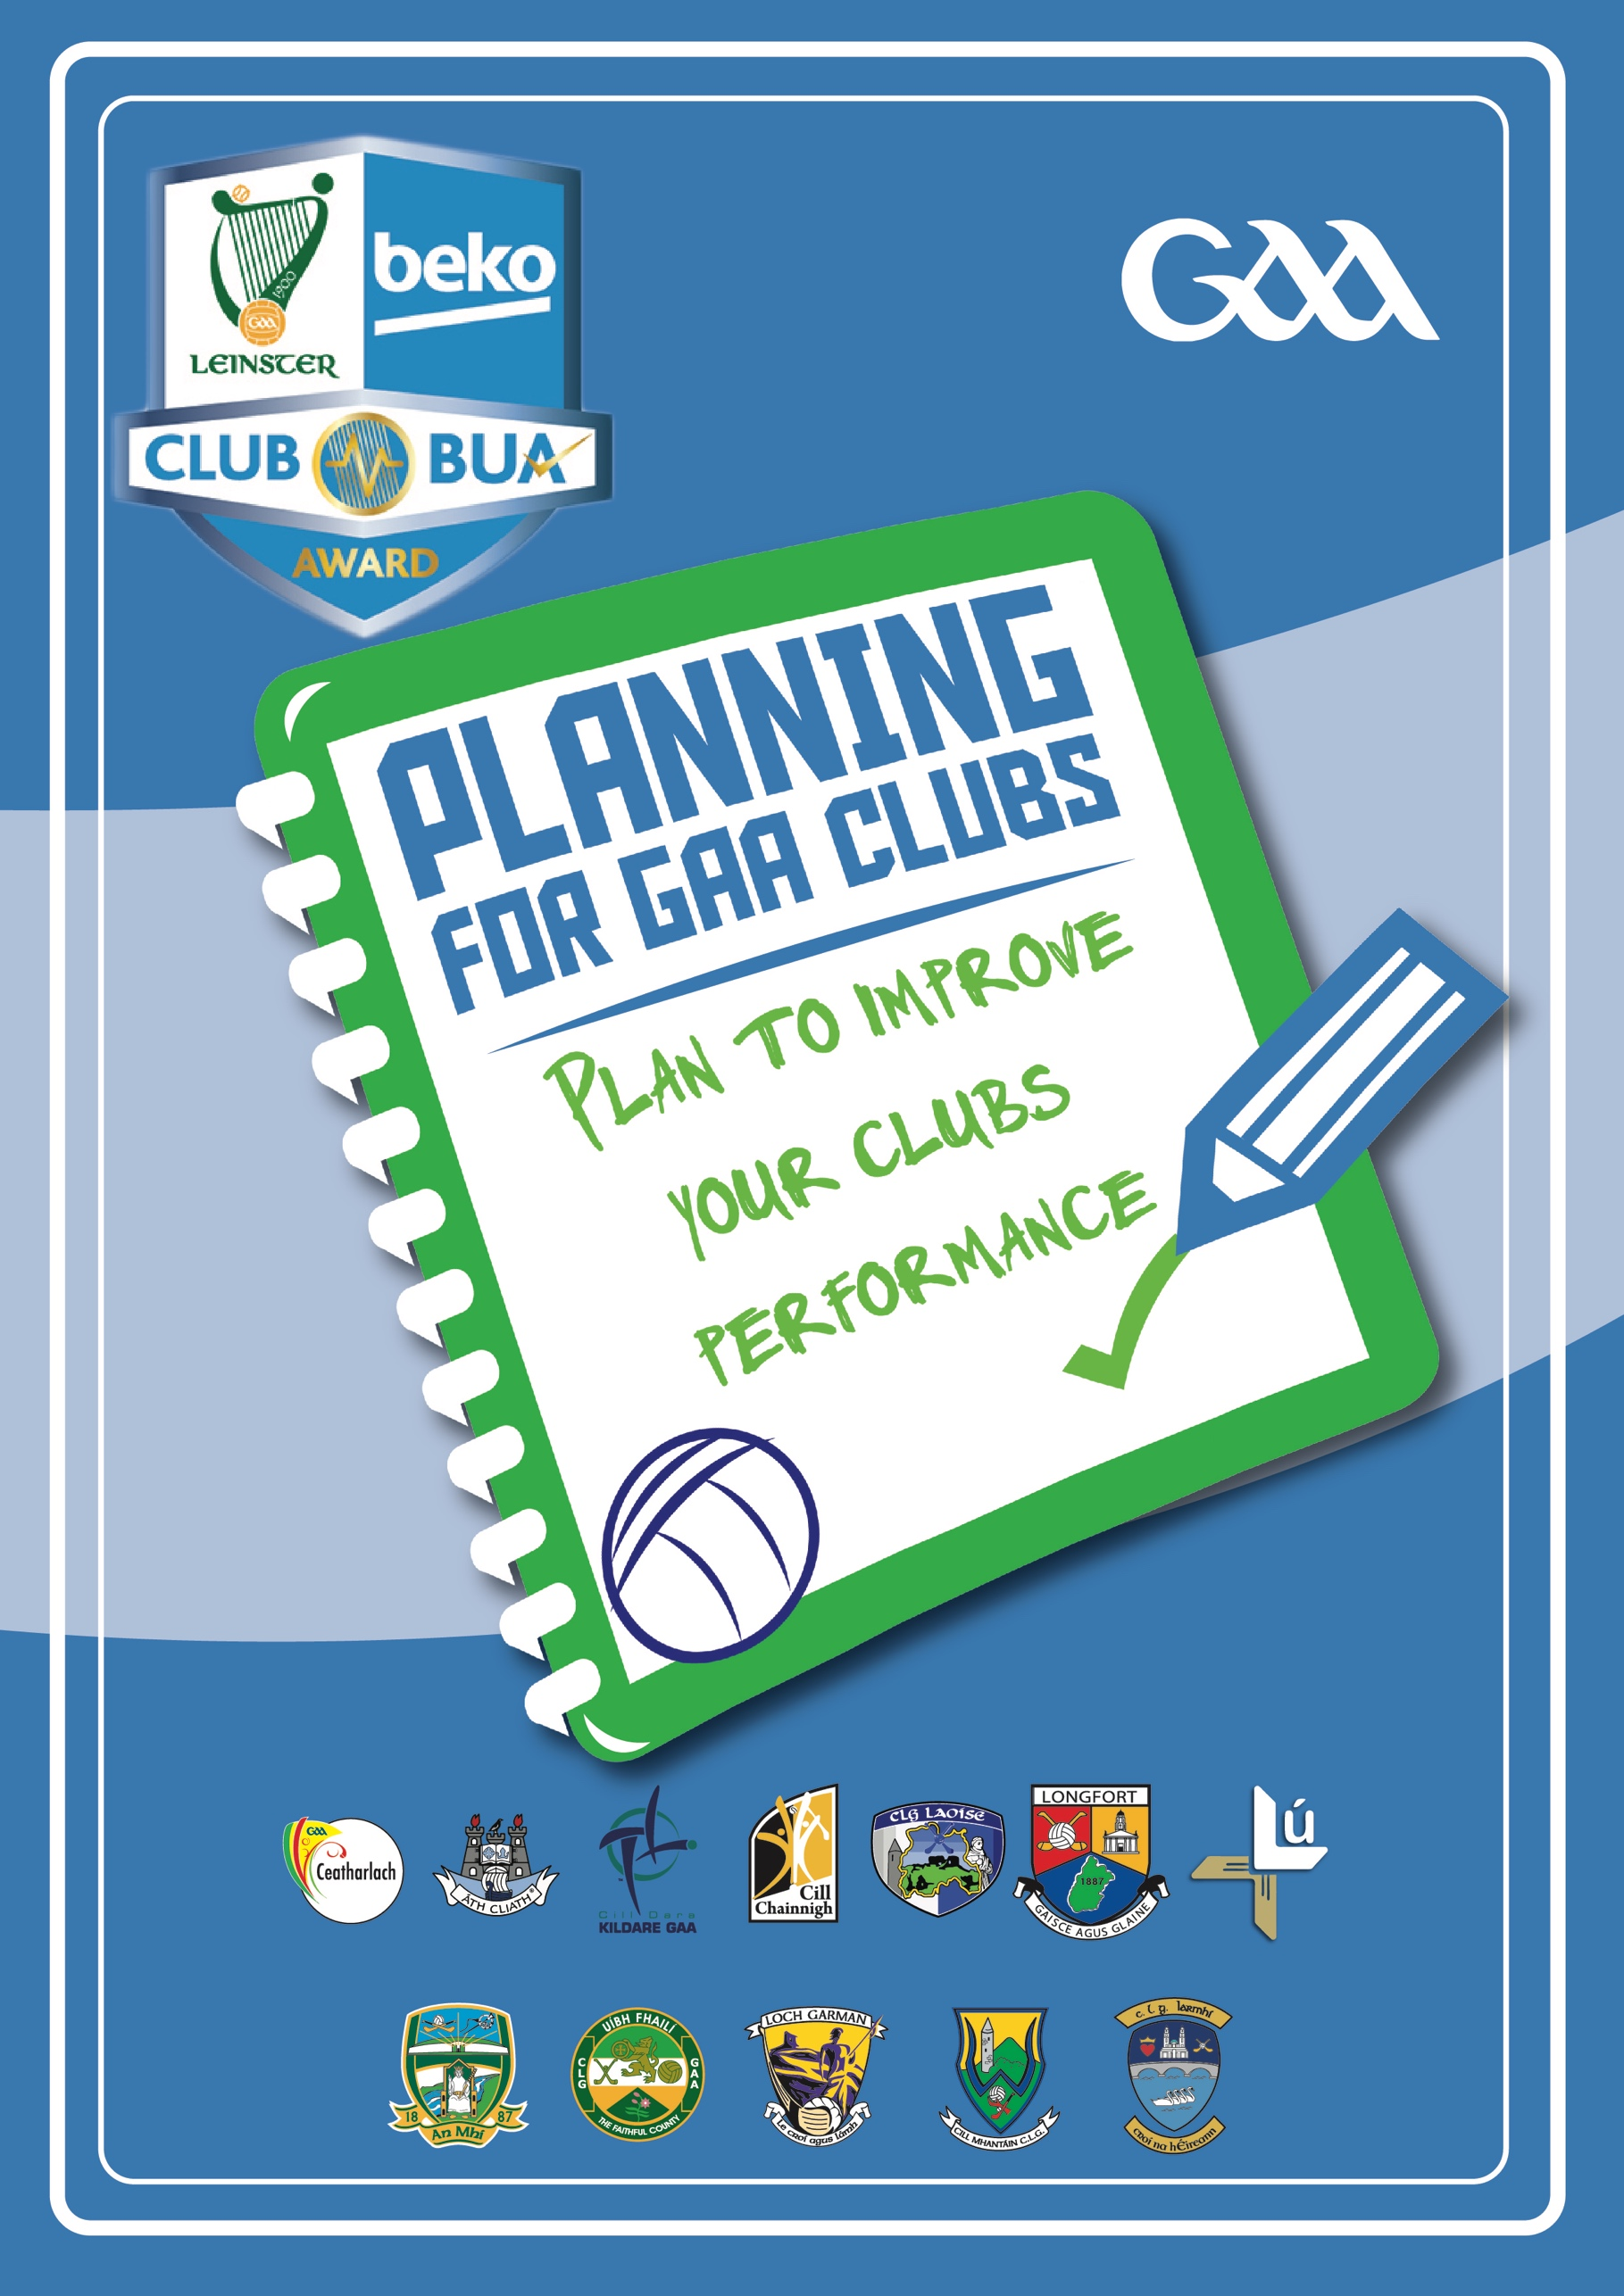
What is the Programme?
Club BUA is a resource developed by Leinster Games Developed Section as part of overall GAA Club Development Programme, modified and adapted for use by clubs under the auspices of Leinster GAA.
The planning programme is an initiative by Leinster GAA and its delivery is supported province wide by Games Development Officers, focused on improving the coaching and games aspect within your club in line with good practice.
The purpose of club BUA is to provide clubs with a practical tool to assist your club get an understanding of:
Where your club is now
Where Your Club Wants to Be
How your club will get there
Club BUA is user friendly and designed in such a way to enable and empower club members to carry out a review of current situation and develop a plan to improve the overall performance of your club teams.
Once the details below been completed your club, please return the application form to info.leinster@gaa.ie.
Club Details

Club Name

Club Address

Club Secretary

Email

Club Coaching Officer

Please complete the following checklist as applicable to your club and codes played
sECTION 1. wHERE ARE YOU NOW?
activity audit – football

BOYS | Nursery | u7 | u8 | u9 | u10 | u12 | u13 | u15 | u17
1 No. of Players
2 No. of Teams
3 No. of County Organised Games per year
4 No. of Club run Blitzes
5 No. of Challenge Games
6 No of Coaches per Team
7 No. of GAA Qualified per Team
8 No.of young referees
9 No. of Weeks of Activity
10 No. of Coaching Sessions
GIRLS | Nursery | u7 | u8 | u9 | u10 | u12 | u13 | u15 | u17
1 No. of Players
2 No. of Teams
3 No. of County Organised Games per year
4 No. of Club run Blitzes
5 No. of Challenge Games
6 No of Coaches per Team
7 No. of GAA Qualified per Team
8 No.of young referees
9 No. of Weeks of Activity
10 No. of Coaching Sessions

activity audit - Hurling
BOYS | Nursery | u7 | u8 | u9 | u10 | u12 | u13 | u15 | u17
1 No. of Players
2 No. of Teams
3 No. of County Organised Games per year
4 No. of Club run Blitzes
5 No. of Challenge Games
6 No of Coaches per Team
7 No. of GAA Qualified per Team
8 No.of young referees
9 No. of Weeks of Activity
10 No. of Coaching Sessions

activity audit - camogie
GIRLS | Nursery | u7 | u8 | u9 | u10 | u12 | u13 | u15 | u17
1 No. of Players
2 No. of Teams
3 No. of County Organised Games per year
4 No. of Club run Blitzes
5 No. of Challenge Games
6 No of Coaches per Team
7 No. of GAA Qualified per Team
8 Number of young referees
9 No. of Weeks of Activity
10 No. of Coaching Sessions

1 (b) WHERE ARE YOU NOW?
club structure
YES NO
a) Does your club have a Coaching & Games Committee in place?
b) Does your club have a Club Coaching Officer/Coordinator in place?
c) Does your club have a Children Officer?
d) Are a all new club coaches Garda Vetted?
e) Does your club have a Code of Conduct for Coaches, Players and Parents?
f) Does your club have a newsletter promoting games and underage activities?
g) Does your club hold a registration day?
h) Do your club coaches plan and review activities annually?
i) Does your club promote the GAA RESPECT Programme?
j) Does your club track/record player participation?
h) Do your club coaches meet regularly over the year to share experiences and progress?
community links
YES NO
a) Does your club have a Club/School Link Scheme in place?
b) Does your club help with local Cumann na mBunscol teams(s)?
c) Does your club support local Post-Primary School(s)?
d) Does the club monitor local population trends?
e) Does your club organise community fun days?
f) Does your club organise any social inclusion initiatives?
g) Are children with disabilities included in activities?
coach education
YES NO
a) Does each team have at least one coach with a Coaching Qualification (Award 1 in line with GAA Mandatory Coaching Standards?
b) Have all your coaches participated in Child Protect Course (Safeguarding 1) before getting involved with coaching children?
c) Are all coaches Garda Vetted before getting involved with coaching children?
d) Does each team have at least one person qualified in First Aid?
e) Do club coaches attend county Coach Education workshops such as TURAS, GAA 15, etc?
f) Are all new coaches asked to complete GAA Foundation Course?
g) Do your club coaches give players/parents feedback?

the Games
YES NO
a) Does your club host a GAA Cul Camp?
b) Does your club organise a second club camp such as at Summer, Easter or Halloween?
c) Does your club participate and promote Go Games?
d) Does your club organise street leagues or host Go Games blitzes?
e) Does your club organise blitzes for teenage players ?
f) Does your club organise Social/Fun Days for players?
g) Is your club active in playing challenge games to provide additional games?
h) Are coaching sessions regular?
i) Is indoor activity provided during the winter?
j) Is drop-out a problem in the club among teenage players?
k) Does the club organise youth forum?
l) Does the club have active young referees?
m) Does your club have an active Nursery (4-6 year olds) in place?
n) Does your club do any skills testing with players?
o) Does your club go play teams from outside of the county?
p) Has participation in club increased over last 2-3 years?

2. WHERE YOU WANT TO BE

In this section review the checklists and through a SWOT Analysis exercise identify what are the Strengths, Weaknesses, Opportunities and Threats related to your clubs. Carry out this exercise in a group setting.

Strengths | Weaknesses
Opportunities | Threats

2. WHERE YOU WANT TO BE

rEVIEW THE RESULTS OF THE swot aNALYSIS AND AS A GROUP, AGREE WHAT SHOULD BE THE CLUBS EXPECTAIONS FOR THE NEXT 1, 2 OR 3 YEARS. iN A GROUP SET OUT WHAT THE KEY PRIORITIES ARE FOR THE CLUB GOING FORWARD. tHESE SHOULD BE CRITICAL TO THE IMPROVEMENT OF THE CLUB.

What are the four key priorities for your Club in tHE NEXT 1, 2 OR 3 YEARS?

5.
6.
7.

tURAS cOACHING pRINCAPALS

wHEN YOUR COACHES COACH, DOES IT LOOK LIKE THIS?

t – Testing & challenging, all players should be challeneged to improve at their level

U – understand the player is at the center of the game and provide indiviualised development

R – Resembeles the game (Game based)

a – all the players involves all of the time. lots of touches, lots of decisions.

s – Should always be an enjoyable, appropriate & holistic gaa experience.

SECTION 3: HOW YOUR CLUB WILL GET THERE
hAVING COMPLETED THE PREVIOUS EXERCISES AND IDENTIFIED WHAT THE KEY PRIORITIES ARE – THE NEXT STEP IS TO SET OUR HOW THE CLUB WILL ACHIEVE ITS ECXPECTATION BY SETTING WHAT WILL BE DONE, hOW IT WILL BE DONE, BY wHOM AND BY WHEN. tHIS IS THE MOST CRITICAL PART OF THE PROCESS AS IT IS A SHARED CONTRACT OR AGREEMENT MADE BETWEEN THE MEMBERS COMMITTED TO IMPROVING THE CLUB. tHIS AGAIN should BE COMPLETED BY ASKING THE OVERALL GROUP TO SPLIT AND TAKE EACH PRIROTY AREA AND GIVE FEEDBACK ON FOR AGREEMENT.

a GROUP SHOULD BE ESTABLISED TO OVERSEE IMPLEMENTATION OF THE ACTION PLAN AND IT SHOULD BE REVIEWED AND EVALUATED ON AT CLUB MEETINGS.

Action Plan Template

Area | Actions | When | Who
Player Recruitment | Club Nursery in place for 4-7-year olds | April-September 2018 | Coaching Committee
Club notes:

