DECLARATION OF SUITABILITY 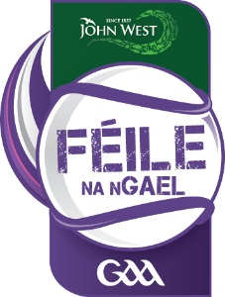
HOST FAMILY
This form must be completed by any person 18 yrs of age and over who resides in the Host Family home during the Féile Peile na nÓg hosting period who has submitted their host family vetting application form and has yet to receive their GAA Garda vetting acceptance letter from Croke Park.
I ______________________________________________________________________________________________
confirm that there is nothing in my personal or professional background that may deem me unsuitable to act in a Host Family capacity during Féile na nGael 2016.
I further declare that there are no convictions/prosecutions recorded against me in Ireland or elsewhere, pending or completed, that may deem me unsuitable to act in a Host Family capacity.
I declare that this statement and that the information contained in my Garda vetting application/Police background check (if applicable) is accurate and I agree to abide by the directions given to me by my Club Féile Coordinator.
NAME: ________________________________________________________________________________
ADDRESS: ________________________________________________________________________________
CLUB: ________________________________________________________________________________
SIGNED: ________________________________ DATE: ________________________________________
HOSTED PLAYERS: _________________________________ _____________________________________

Please return this form to the Club Féile Coordinator

